TY IT-1(BATCH A)

DCDR
150410116018

DESAI JAIMIN

Practical 4:- Implement Huffman Algorithm to generate code when symbol and probabilities are given.

Program:

#include<iostream.h>

#include<string.h>

#include<math.h>

#include<stdlib.h>

#include<conio.h>

struct tree

{

char a[20];

int s;

struct tree *left,*right;

}*root=NULL,*tt[20]={NULL},*temp,*temp2,*t2,*ri,*le;

struct pqu

{

int info;

char a[20];

struct pqu *ptr;

}*front=NULL,*t,*par,*t1,*p1,*p2;

struct pqu* fp(int info)

{

struct pqu *p=NULL;

for(t1=front;t1->info<info&&t1!=NULL;t1=t1->ptr)

{

p=t1;

}

return (p);

}

void enqu(char a[20],int p)

{

t=(struct pqu*)malloc(sizeof(struct pqu));

strcpy(t->a,a);

t->info=p;

t->ptr=NULL;

if(front==NULL)

{

front=t;

}

SVIT - VASAD Page 8

TY IT-1(BATCH A)

DCDR
150410116018

DESAI JAIMIN

else

{

par=fp(p);

if(par==NULL)

{

t->ptr=front;

front=t;

}

else

{

t->ptr=par->ptr;

par->ptr=t;

}

}

}

struct pqu* dequ()

{

t1=front;

front=front->ptr;

return t1;

}

void info(char c[2])

{

int m=0,i;

temp2=root;

while(strcmp(c,temp2->a)!=0)

{

t2=temp2->left;

for(i=0;i<strlen(t2->a);i++)

{

if(t2->a[i]==c[0])

{

temp2=temp2->left;

m=1;

cout<<"0";

break;

}

}

if(m!=1)

{

temp2=temp2->right;

cout<<1;

}

SVIT - VASAD Page 9

TY IT-1(BATCH A)

DCDR
150410116018

DESAI JAIMIN

m=0;

}

}

void insert()

{

char a1[20],b1[20],v1[20];

int i,j,z=0,l;

while(front!=NULL)

{

p1=dequ();

strcpy(a1,p1->a);

l=p1->info;

p2=dequ();

if(p2==NULL)

break;

strcpy(b1,p2->a);

strcpy(v1,a1);

temp=(struct tree*)malloc(sizeof(struct tree));

strcpy(temp->a,strcat(v1,b1));

temp->s=l+p2->info;

temp->left=NULL;

temp->right=NULL;

temp2=temp;

root=temp;

for(i=0;i<z;)

{

if(strcmp(tt[i]->a,a1)==0)

{

temp->left=tt[i];

for(l=i;l<z;l++)

{

tt[l]=tt[l+1];

}

i=0;

continue;

}

else if(strcmp(tt[i]->a,b1)==0)

{

temp->right=tt[i];

for(l=i;l<z;l++)

{

tt[l]=tt[l+1];

}

SVIT - VASAD Page 10

TY IT-1(BATCH A)

DCDR
150410116018

DESAI JAIMIN

i=0;

continue;

}

i++;

}

if(temp->left==NULL)

{

le=(struct tree*)malloc(sizeof(struct tree));

strcpy(le->a,a1);

le->left=NULL;

le->right=NULL;

temp2->left=le;

}

if(temp->right==NULL)

{

ri=(struct tree*)malloc(sizeof(struct tree));

strcpy(ri->a,b1);

ri->left=NULL;

ri->right=NULL;

temp2->right=ri;

}

if(front!=NULL)

enqu(temp2->a,temp2->s);

tt[z++]=temp2;

}

}

void disp(struct tree *rt)

{

if(rt!=NULL)

{

disp(rt->left);

cout<<" "<<rt->a;

disp(rt->right);

}

}

void main()

{

textmode(MONO);

int i=0,g,h,p,y,n;

char m[20],b[20][2],re;

while(1)

{

clrscr();

SVIT - VASAD Page 11

TY IT-1(BATCH A)

DCDR
150410116018

DESAI JAIMIN

cout<<"===";

cout<<"\n HUFFMAN CODING";

cout<<"===";

cout<<"\n Enter the total no of characters : ";

cin>>n;

for(i=0;i<n;i++)

{

cout<<"Enter the character : ";

cin>>m;

strcpy(b[i],m);

cout<<"Enter frequency for "<<m<<" : ";

cin>>g;

enqu(m,g);

}

insert();

disp(root);

clrscr();

cout<<"===";

cout<<"\n The corresponding codes are.....";

cout<<"===";

for(i=0;i<n;i++)

{

cout<<"\n "<<b[i]<<" : ";

info(b[i]);

}

cout<<"DO YOU WANT TO CONTINUE Y OR N: ";

cin>>re;

if(re=='y'||re=='Y')

continue;

else

exit(0);

}

}

SVIT - VASAD Page 12

TY IT-1(BATCH A)

DCDR
150410116018

DESAI JAIMIN

Output:-

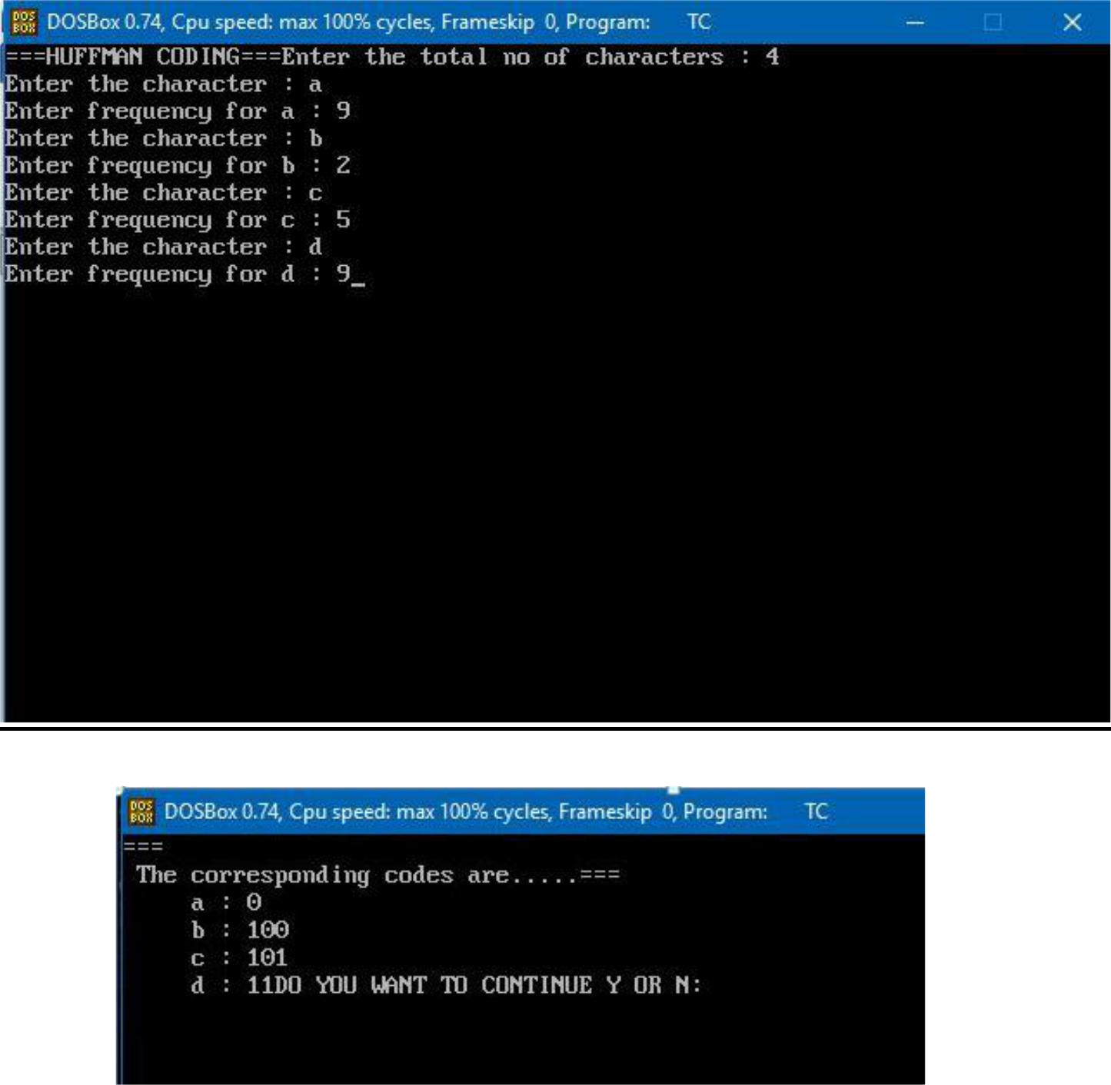

SVIT - VASAD Page 13

TY IT-1(BATCH A)

DCDR
150410116018

DESAI JAIMIN

PRACTICAL-5

Aim: Implementation of Adaptive Huffman Algorithm

Program:

#include <stdio.h>
#include <stdlib.h>
#define MAX_TREE_HT 100
struct MinHeapNode
{
char data;
unsigned freq;

struct MinHeapNode *left, *right;
};
struct MinHeap
{
unsigned size;
unsigned capacity;
struct MinHeapNode **array;
};
struct MinHeapNode* newNode(char data, unsigned freq)
{
struct MinHeapNode* temp =

(struct MinHeapNode*) malloc(sizeof(struct MinHeapNode)); temp->left = temp->right = NULL; temp->data = data;

temp->freq = freq;
return temp;
}
struct MinHeap* createMinHeap(unsigned capacity)
{
struct MinHeap* minHeap =

(struct MinHeap*) malloc(sizeof(struct MinHeap)); minHeap->size = 0; // current size is 0 minHeap->capacity = capacity; minHeap->array =

(struct MinHeapNode**)malloc(minHeap->capacity * sizeof(struct MinHeapNode*)); return minHeap;

}
void swapMinHeapNode(struct MinHeapNode** a, struct MinHeapNode** b)
{
struct MinHeapNode* t = *a;
*a = *b;
*b = t;
}
void minHeapify(struct MinHeap* minHeap, int idx)
{
int smallest = idx;

SVIT - VASAD Page 14

TY IT-1(BATCH A)

DCDR
150410116018

DESAI JAIMIN

int left = 2 * idx + 1;
int right = 2 * idx + 2;

if (left < minHeap->size &&
minHeap->array[left]->freq < minHeap->array[smallest]->freq)
smallest = left;
if (right < minHeap->size &&
minHeap->array[right]->freq < minHeap->array[smallest]->freq)
smallest = right;
if (smallest != idx)
{

swapMinHeapNode(&minHeap->array[smallest], &minHeap->array[idx]); minHeapify(minHeap, smallest);

}

}

- A utility function to check if size of heap is 1 or not int isSizeOne(struct MinHeap* minHeap)

{
return (minHeap->size == 1);
}

- A standard function to extract minimum value node from heap struct MinHeapNode* extractMin(struct MinHeap* minHeap)
{

struct MinHeapNode* temp = minHeap->array[0]; minHeap->array[0] = minHeap->array[minHeap->size - 1]; --minHeap->size;

minHeapify(minHeap, 0); return temp;

}
- A utility function to insert a new node to Min Heap

void insertMinHeap(struct MinHeap* minHeap, struct MinHeapNode* minHeapNode) {

++minHeap->size;
int i = minHeap->size - 1;
while (i && minHeapNode->freq < minHeap->array[(i - 1)/2]->freq)
{

minHeap->array[i] = minHeap->array[(i - 1)/2]; i = (i - 1)/2;

}
minHeap->array[i] = minHeapNode;

}
// A standard funvtion to build min heap
void buildMinHeap(struct MinHeap* minHeap)
{
int n = minHeap->size - 1;
int i;
for (i = (n - 1) / 2; i >= 0; --i)
minHeapify(minHeap, i);
}
void printArr(int arr[], int n)

SVIT - VASAD Page 15

TY IT-1(BATCH A)

DCDR
150410116018

DESAI JAIMIN

{
int i;
for (i = 0; i < n; ++i)
printf("%d", arr[i]);
printf("\n");
}
int isLeaf(struct MinHeapNode* root)
{
return !(root->left) && !(root->right) ;
}
struct MinHeap* createAndBuildMinHeap(char data[], int freq[], int size)
{

struct MinHeap* minHeap = createMinHeap(size); for (int i = 0; i < size; ++i)

minHeap->array[i] = newNode(data[i], freq[i]);
minHeap->size = size;
buildMinHeap(minHeap);
return minHeap;
}
struct MinHeapNode* buildHuffmanTree(char data[], int freq[], int size)
{
struct MinHeapNode *left, *right, *top;
struct MinHeap* minHeap = createAndBuildMinHeap(data, freq, size);
while (!isSizeOne(minHeap))
{
left = extractMin(minHeap);
right = extractMin(minHeap);

top = newNode('$', left->freq + right->freq);
top->left = left;
top->right = right;
insertMinHeap(minHeap, top);
}
return extractMin(minHeap);
}
void printCodes(struct MinHeapNode* root, int arr[], int top)
{
if (root->left)
{

arr[top] = 0;
printCodes(root->left, arr, top + 1);
}
if (root->right)
{
arr[top] = 1;
printCodes(root->right, arr, top + 1);
}
if (isLeaf(root))
{

SVIT - VASAD Page 16

TY IT-1(BATCH A)

DCDR
150410116018

DESAI JAIMIN

printf("%c: ", root->data);
printArr(arr, top);
}
}
void HuffmanCodes(char data[], int freq[], int size)
{

struct MinHeapNode* root = buildHuffmanTree(data, freq, size); int arr[MAX_TREE_HT], top = 0; printCodes(root, arr, top);

}
int main()
{
char arr[] = {'a', 'b', 'c', 'd', 'e', 'f'};
int freq[] = {5, 9, 12, 13, 16, 45};

int size = sizeof(arr)/sizeof(arr[0]);
HuffmanCodes(arr, freq, size);
return 0;
}

OUTPUT:-

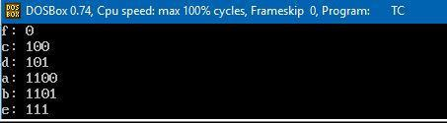

SVIT - VASAD Page 17

TY IT-1(BATCH A)

DCDR
150410116018

DESAI JAIMIN

PRACTICAL-6

Aim: Implementation of Arithmetic Algorithm

#include<stdio.h>

#include<conio.h>

#include<string.h>

#include<math.h>

struct node

{

char c;

int cnt;

double p,lb,ub;

};

void ublb(int,double,double);

struct node n[100];

void main()

{

char ch,*input;

double prob=0,lb,ub,UB=1,LB=0;

int i,j,size=0,flag=0,t=0;

clrscr();

printf("Enter String to be Coded:");

gets(input);

while(size<strlen(input))

{printf("%c",input[size]); flag=0; for(j=0;j<t;j++)
{

if(input[size]==n[j].c)

{

flag=1;

n[j].cnt++;

break; }

}

if (flag==0)

{

n[t].c=input[size];

n[t].cnt=1;

t++; }

size++;

}

printf("\nLength of String:%d\n",size);

printf("Symbol________Count______Lower Bound_Upper Bound\n ");

SVIT - VASAD Page 18

TY IT-1(BATCH A)

DCDR
150410116018

DESAI JAIMIN

prob=0;

for(i=0;i<t;i++)

{

n[i].p=n[i].cnt/(float)size;

ublb(i,prob,n[i].p);

prob+=n[i].p;

printf("\nSymbol:%c\t%d\t[%f,%f)",n[i].c,n[i].cnt,n[i].lb,n[i].ub);

}

i=0;

printf("\nTAGS:");

while(i<strlen(input))

{

flag=0;

ch=input[i];

for(j=0;j<t;j++)

{

if(ch==n[j].c)

{

lb=LB+(UB-LB)*(n[j].lb);

ub=LB+(UB-LB)*(n[j].ub);

break;

}

}

printf("\nSYMBOL:%c\t[%f,%f)",input[i],lb,ub);

UB=ub;

LB=lb;

i++;

}

printf("\nFinal Tag for %s:%f",input,(UB+LB)/2);

getch();

}

void ublb(int i,double cp,double np)

{

if(cp<1)

{

n[i].lb=cp;

n[i].ub=cp+np;

}

}

SVIT - VASAD Page 19

TY IT-1(BATCH A)

DCDR
150410116018

DESAI JAIMIN

OUTPUT:-
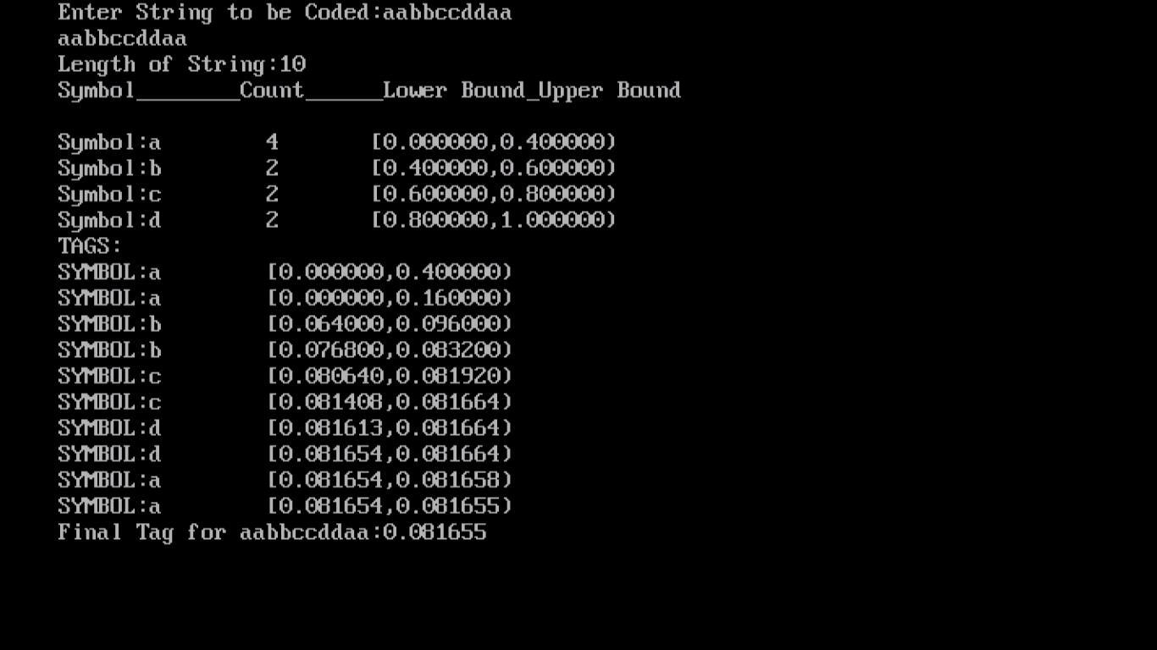

SVIT - VASAD Page 20

TY IT-1(BATCH A) |  |  |  | DCDR |  | 150410116018
 |  |  |  |  |  | DESAI JAIMIN
 |  |  |  | PRACTICAL-7
 |  |  | Aim: Implementation of LZ77 Algorithm.
 | Program:

#include<stdio.h>

#include<conio.h>

#include<string.h>

#include<stdlib.h>

char code[100][10];

char string[]="BAABABBBAABBBBAA";

int index=1;

void secondpass();

int check(char[],int);

void findindex(char[],int);

void printDict();

void main()

{

clrscr();

printf("String:%s\n",string);

printf("Length:%d\nCoded INDEX:",strlen(string));

//finding individual symbols

secondpass();

printDict();

getch();

}

void secondpass()

{

int i=0,j,flag=0,k;

char tstring[10],tstr;

while(string[i]!='\0')

{

flag=0;

k=0;

tstring[0]=string[i];

while(!flag)

{

tstr=tstring[k];

flag=check(tstring,k);

if(flag==1)

{

findindex(tstring,k);

printf("C(%c)>\n",tstr);

SVIT - VASAD Page 21

TY IT-1(BATCH A)

DCDR
150410116018

DESAI JAIMIN

strncpy(code[index],tstring,k+1);

code[index][k+1]='\0';

index++;

i=i+k+1;

break; }

else

{

k++;

if(string[i+k]!='\0')

{

tstring[k]=string[i+k];}

else

{

findindex(tstring,k);

i++;break;

}

}

}

}

}

int check(char *str,int k)

{

int i=1,j=0,flag;

while(i<=index)

{

flag=0;

for(j=0;j<=k;j++)

{ if (code[i][j]!=str[j])

{flag=1;

break;

}

}

if(!flag) return 0;

i++;

}

return 1;

}

//OK

void printDict()

{

int i;

for(i=1;i<index;i++)

{

SVIT - VASAD Page 22

TY IT-1(BATCH A)

DCDR
150410116018

DESAI JAIMIN

printf("\nINDEX:%8d\tCODE:%5s ",i,code[i]);

}

}

//OK

void findindex(char *str,int k)

{

int i=0,flag;

while(i<=index)

{

flag=0;

flag=strncmp(code[i],str,k);

if(flag==0)

{

printf("<%d,",i);

return ; }

else

i++;

}

return ;

}

OUTPUT:

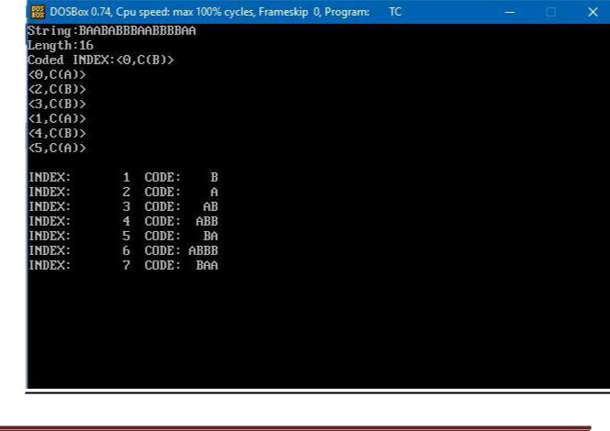

SVIT - VASAD Page 23

TY IT-1(BATCH A) |  |  | DCDR |  | 150410116018
 |  |  |  |  | DESAI JAIMIN
 |  |  | PRACTICAL-8
 |  | Aim: Implementation of LZ78 algorithm
 | Program:

#include<stdio.h>

#include<conio.h>

#include<string.h>

#include<stdlib.h>

char code[100][10];

char string[]="WABBA WABBA WABBA WABBA WOO WOO WOO";

int index=1;

void firstpass();

void secondpass();

int check(char[],int);

void findindex(char[],int);

void printDict();

void main()

{

clrscr();

printf("String:%s\n",string);

printf("Length:%d",strlen(string));

//finding individual symbols

printf("CALLING FIRST PASS\n");

firstpass();

printDict();

printf("AFTER CALLING FIRST PASS\n");

secondpass();

printDict();

getch();

}

//OK

void firstpass()

{

int i=0,j,flag;

char ch;

while(string[i]!='\0')

{

ch=string[i];

if(index==1)

{

code[index][0]=ch;

SVIT - VASAD Page 24

TY IT-1(BATCH A)

DCDR
150410116018

DESAI JAIMIN

index++; }

else

{

flag=1;

for(j=1;j<index;j++)

{

if (code[j][0]==ch)

{

flag=0;

break;

}

}

if(flag)

{

code[index][0]=ch;

index++; }

}

i++;

}

}

void secondpass()

{

int i=0,j,flag=0,k;

char tstring[10],tstr[10];

while(string[i]!='\0')

{

flag=0;

k=0;

tstring[0]=string[i];

while(!flag)

{

strncpy(tstr,tstring,k+1);

flag=check(tstring,k);

if(flag==1)

{

findindex(tstr,k);

strncpy(code[index],tstring,k+1);

code[index][k+1]='\0';

index++;

i=i+k;

break; }

else

{

k++;

SVIT - VASAD Page 25

TY IT-1(BATCH A)

DCDR
150410116018

DESAI JAIMIN

if(string[i+k]!='\0')

{

tstring[k]=string[i+k];}

else

{

findindex(tstr,k);

i++;break;

}

}

}

}

}

int check(char *str,int k)

{

int i=1,j=0,flag;

while(i<index)

{

flag=0;

for(j=0;j<=k;j++)

{ if (code[i][j]!=str[j])

{flag=1;

break;

}

}

if(!flag) return 0;

i++;

}

return 1;

}

//OK

void printDict()

{

int i;

for(i=1;i<index;i++)

{

printf("\nINDEX:%d\tCODE:%s:%d",i,code[i],strlen(code[i]));

}

}

//OK

void findindex(char str[10],int k)

{

int i=1,flag;

while(i<=index)

SVIT - VASAD Page 26

TY IT-1(BATCH A)

DCDR
150410116018

DESAI JAIMIN

{

flag=0;

flag=strncmp(code[i],str,k);

if(flag==0)

{

printf("%d ",i);

return ; }

else

i++;

}

return ;

}

OUTPUT:-

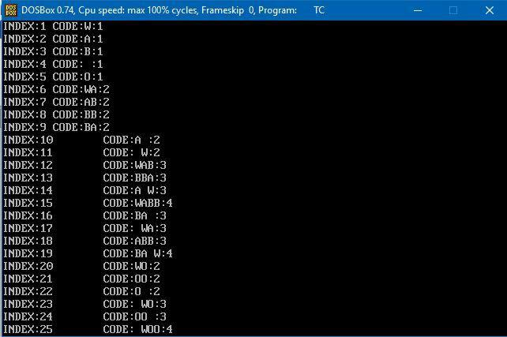

SVIT - VASAD Page 27

TY IT-1(BATCH A)

DCDR
150410116018

DESAI JAIMIN

PRACTICAL:9

AIM: IMPEMENTATION OF JPEG ALGORITHM.

/*

- example.c

- This file illustrates how to use the IJG code as a subroutine library

- to read or write JPEG image files. You should look at this code in

- conjunction with the documentation file libjpeg.doc.

*

- This code will not do anything useful as-is, but it may be helpful as a

- skeleton for constructing routines that call the JPEG library.

*

- We present these routines in the same coding style used in the JPEG code

- (ANSI function definitions, etc); but you are of course free to code your

- routines in a different style if you prefer.

*/

#include <stdio.h>

/*

- Include file for users of JPEG library.

- You will need to have included system headers that define at least

- thetypedefs FILE and size_t before you can include jpeglib.h.

- (stdio.h is sufficient on ANSI-conforming systems.)

- You may also wish to include "jerror.h".

SVIT - VASAD Page 28

TY IT-1(BATCH A)

DCDR
150410116018

DESAI JAIMIN

*/

#include "jpeglib.h"

/*

- <setjmp.h> is used for the optional error recovery mechanism shown in

- the second part of the example.

*/

#include <setjmp.h>

/******************** JPEG COMPRESSION SAMPLE INTERFACE *******************/

/* This half of the example shows how to feed data into the JPEG compressor.

- We present a minimal version that does not worry about refinements such

- as error recovery (the JPEG code will just exit() if it gets an error).

*/

/*

- IMAGE DATA FORMATS:

- The standard input image format is a rectangular array of pixels, with

- each pixel having the same number of "component" values (color channels).

- Each pixel row is an array of JSAMPLEs (which typically are unsigned chars).

- If you are working with color data, then the color values for each pixel

- must be adjacent in the row; for example, R,G,B,R,G,B,R,G,B,... for 24-bit

- RGB color.

*

* For this example, we'll assume that this data structure matches the way

SVIT - VASAD Page 29

TY IT-1(BATCH A)

DCDR
150410116018

DESAI JAIMIN

- our application has stored the image in memory, so we can just pass a

- pointer to our image buffer. In particular, let's say that the image is

- RGB color and is described by:

*/

extern JSAMPLE * image_buffer; /* Points to large array of R,G,B-order data */

externintimage_height; /* Number of rows in image */

externintimage_width; /* Number of columns in image */

/*

- Sample routine for JPEG compression. We assume that the target file name

- and a compression quality factor are passed in.

*/

GLOBAL(void)

write_JPEG_file (char * filename, int quality)

{

/* Thisstruct contains the JPEG compression parameters and pointers to

- working space (which is allocated as needed by the JPEG library).

- It is possible to have several such structures, representing multiple

- compression/decompression processes, in existence at once. We refer

- to any one struct (and its associated working data) as a "JPEG object". */

structjpeg_compress_structcinfo;

/* Thisstruct represents a JPEG error handler. It is declared separately

  - because applications often want to supply a specialized error handler

- (see the second half of this file for an example). But here we just

  - take the easy way out and use the standard error handler, which will

  - print a message on stderr and call exit() if compression fails.

SVIT - VASAD Page 30

TY IT-1(BATCH A) DCDR

- Note that this struct must live as long as the main JPEG parameter

- struct, to avoid dangling-pointer problems.

*/

structjpeg_error_mgrjerr;

/* More stuff */

FILE * outfile; /* target file */

JSAMPROW row_pointer[1]; /* pointer to JSAMPLE row[s] */

introw_stride; /* physical row width in image buffer */

/* Step 1: allocate and initialize JPEG compression object */

/* We have to set up the error handler first, in case the initialization

  - step fails. (Unlikely, but it could happen if you are out of memory.)

  - This routine fills in the contents of structjerr, and returns jerr's

- address which we place into the link field in cinfo. */

cinfo.err = jpeg_std_error(&jerr);

/* Now we can initialize the JPEG compression object. */ jpeg_create_compress(&cinfo);

/* Step 2: specify data destination (eg, a file) */

/* Note: steps 2 and 3 can be done in either order. */

/* Here we use the library-supplied code to send compressed data to a

- stdio stream. You can also write your own code to do something else.

- VERY IMPORTANT: use "b" option to fopen() if you are on a machine that

- requires it in order to write binary files.

150410116018 DESAI JAIMIN

SVIT - VASAD Page 31

TY IT-1(BATCH A)

DCDR
150410116018

DESAI JAIMIN

*/

if ((outfile = fopen(filename, "wb")) == NULL) {

fprintf(stderr, "can't open %s\n", filename);

exit(1);

}

jpeg_stdio_dest(&cinfo, outfile);

/* Step 3: set parameters for compression */

/* First we supply a description of the input image.

- Four fields of the cinfostruct must be filled in: */

cinfo.image_width = image_width; /* image width and height, in pixels */

cinfo.image_height = image_height;

cinfo.input_components = 3; /* # of color components per pixel */

cinfo.in_color_space = JCS_RGB; /* colorspace of input image */

/* Now use the library's routine to set default compression parameters.

- (You must set at least cinfo.in_color_space before calling this,

- since the defaults depend on the source color space.)

*/

jpeg_set_defaults(&cinfo);

/* Now you can set any non-default parameters you wish to.

- Here we just illustrate the use of quality (quantization table) scaling: */

jpeg_set_quality(&cinfo, quality, TRUE /* limit to baseline-JPEG values */);

/* Step 4: Start compressor */

SVIT - VASAD Page 32

TY IT-1(BATCH A)

DCDR
150410116018

DESAI JAIMIN

/* TRUE ensures that we will write a complete interchange-JPEG file.

- Pass TRUE unless you are very sure of what you're doing. */

jpeg_start_compress(&cinfo, TRUE);

/* Step 5: while (scan lines remain to be written) */

/* jpeg_write_scanlines(...); */

/* Here we use the library's state variable cinfo.next_scanline as the

- loop counter, so that we don't have to keep track ourselves.

- To keep things simple, we pass one scanline per call; you can pass

- more if you wish, though.

*/

row_stride = image_width * 3; /* JSAMPLEs per row in image_buffer */

while (cinfo.next_scanline<cinfo.image_height) {

/* jpeg_write_scanlines expects an array of pointers to scanlines.

- Here the array is only one element long, but you could pass

- more than one scanline at a time if that's more convenient. */

row_pointer[0] = &image_buffer[cinfo.next_scanline * row_stride]; (void) jpeg_write_scanlines(&cinfo, row_pointer, 1);

}

/* Step 6: Finish compression */

SVIT - VASAD Page 33

TY IT-1(BATCH A) DCDR

jpeg_finish_compress(&cinfo);

/* Afterfinish_compress, we can close the output file. */ fclose(outfile);

/* Step 7: release JPEG compression object */

/* This is an important step since it will release a good deal of memory. */ jpeg_destroy_compress(&cinfo);

/* And we're done! */

}

/*

  - SOME FINE POINTS:

  - In the above loop, we ignored the return value of jpeg_write_scanlines,

  - which is the number of scanlines actually written. We could get away

  - with this because we were only relying on the value of cinfo.next_scanline,

  - which will be incremented correctly. If you maintain additional loop

  - variables then you should be careful to increment them properly.

  - Actually, for output to a stdio stream you needn't worry, because

  - thenjpeg_write_scanlines will write all the lines passed (or else exit

- with a fatal error). Partial writes can only occur if you use a data

  - destination module that can demand suspension of the compressor.

  - (If you don't know what that's for, you don't need it.)

*

150410116018 DESAI JAIMIN

SVIT - VASAD Page 34

TY IT-1(BATCH A)

DCDR
150410116018

DESAI JAIMIN

- If the compressor requires full-image buffers (for entropy-coding

- optimization or a multi-scan JPEG file), it will create temporary

- files for anything that doesn't fit within the maximum-memory setting.

- (Note that temp files are NOT needed if you use the default parameters.)

- On some systems you may need to set up a signal handler to ensure that

- temporary files are deleted if the program is interrupted. See libjpeg.doc.

- Scanlines MUST be supplied in top-to-bottom order if you want your JPEG

- files to be compatible with everyone else's. If you cannot readily read

- your data in that order, you'll need an intermediate array to hold the

- image. See rdtarga.c or rdbmp.c for examples of handling bottom-to-top

- source data using the JPEG code's internal virtual-array mechanisms.

*/

/******************** JPEG DECOMPRESSION SAMPLE INTERFACE *******************/

/* This half of the example shows how to read data from the JPEG decompressor.

- It's a bit more refined than the above, in that we show:

- (a) how to modify the JPEG library's standard error-reporting behavior;

- (b) how to allocate workspace using the library's memory manager.

*

- Just to make this example a little different from the first one, we'll

- assume that we do not intend to put the whole image into an in-memory

- buffer, but to send it line-by-line someplace else. We need a one-

- scanline-high JSAMPLE array as a work buffer, and we will let the JPEG

SVIT - VASAD Page 35

TY IT-1(BATCH A) DCDR

- memory manager allocate it for us. This approach is actually quite useful

- because we don't need to remember to deallocate the buffer separately: it

- will go away automatically when the JPEG object is cleaned up.

*/

/*

- ERROR HANDLING:

- The JPEG library's standard error handler (jerror.c) is divided into

- several "methods" which you can override individually. This lets you

- adjust the behavior without duplicating a lot of code, which you might

- have to update with each future release.

*

- Our example here shows how to override the "error_exit" method so that

- control is returned to the library's caller when a fatal error occurs,

- rather than calling exit() as the standard error_exit method does.

*

- We use C's setjmp/longjmp facility to return control. This means that the

- routine which calls the JPEG library must first execute a setjmp() call to

- establish the return point. We want the replacement error_exit to do a

- longjmp(). But we need to make the setjmp buffer accessible to the

- error_exit routine. To do this, we make a private extension of the

- standard JPEG error handler object. (If we were using C++, we'd say we

- were making a subclass of the regular error handler.)

*

* Here's the extended error handler struct:

150410116018 DESAI JAIMIN

SVIT - VASAD Page 36

TY IT-1(BATCH A) DCDR

*/

structmy_error_mgr {

structjpeg_error_mgr pub; /* "public" fields */

jmp_bufsetjmp_buffer; /* for return to caller */

};

typedefstructmy_error_mgr * my_error_ptr;

/*

- Here's the routine that will replace the standard error_exit method: */

METHODDEF(void)

my_error_exit (j_common_ptrcinfo)

{

/* cinfo->err really points to a my_error_mgrstruct, so coerce pointer */ my_error_ptrmyerr = (my_error_ptr) cinfo->err;

/* Always display the message. */

/* We could postpone this until after returning, if we chose. */ (*cinfo->err->output_message) (cinfo);

/* Return control to the setjmp point */

longjmp(myerr->setjmp_buffer, 1);

}

150410116018 DESAI JAIMIN

SVIT - VASAD Page 37

TY IT-1(BATCH A)

DCDR
150410116018

DESAI JAIMIN

/*

- Sample routine for JPEG decompression. We assume that the source file name

- is passed in. We want to return 1 on success, 0 on error.

*/

GLOBAL(int)

read_JPEG_file (char * filename)

{

/* Thisstruct contains the JPEG decompression parameters and pointers to

- working space (which is allocated as needed by the JPEG library). */

structjpeg_decompress_structcinfo;

/* We use our private extension JPEG error handler.

- Note that this struct must live as long as the main JPEG parameter

- struct, to avoid dangling-pointer problems.

*/

structmy_error_mgrjerr;

/* More stuff */

FILE * infile; /* source file */

JSAMPARRAY buffer; /* Output row buffer */

introw_stride; /* physical row width in output buffer */

/* In this example we want to open the input file before doing anything else, * so that the setjmp() error recovery below can assume the file is open.

SVIT - VASAD Page 38

TY IT-1(BATCH A) DCDR

- VERY IMPORTANT: use "b" option to fopen() if you are on a machine that

- requires it in order to read binary files.

*/

if ((infile = fopen(filename, "rb")) == NULL) { fprintf(stderr, "can't open %s\n", filename); return 0;

}

/* Step 1: allocate and initialize JPEG decompression object */

/* We set up the normal JPEG error routines, then override error_exit. */ cinfo.err = jpeg_std_error(&jerr.pub); jerr.pub.error_exit = my_error_exit;

/* Establish the setjmp return context for my_error_exit to use. */ if (setjmp(jerr.setjmp_buffer)) {

/* If we get here, the JPEG code has signaled an error.

- We need to clean up the JPEG object, close the input file, and return. */

jpeg_destroy_decompress(&cinfo);

fclose(infile);

return 0;

}

/* Now we can initialize the JPEG decompression object. */ jpeg_create_decompress(&cinfo);

/* Step 2: specify data source (eg, a file) */

150410116018 DESAI JAIMIN

SVIT - VASAD Page 39

TY IT-1(BATCH A) DCDR

jpeg_stdio_src(&cinfo, infile);

/* Step 3: read file parameters with jpeg_read_header() */

(void) jpeg_read_header(&cinfo, TRUE);

/* We can ignore the return value from jpeg_read_header since

- (a) suspension is not possible with the stdio data source, and

- (b) we passed TRUE to reject a tables-only JPEG file as an error.

- See libjpeg.doc for more info.

*/

/* Step 4: set parameters for decompression */

/* In this example, we don't need to change any of the defaults set by

- jpeg_read_header(), so we do nothing here. */

/* Step 5: Start decompressor */ (void) jpeg_start_decompress(&cinfo);

/* We can ignore the return value since suspension is not possible

- with the stdio data source.

*/

/* We may need to do some setup of our own at this point before reading

- the data. After jpeg_start_decompress() we have the correct scaled

- output image dimensions available, as well as the output colormap

- if we asked for color quantization.

150410116018 DESAI JAIMIN

SVIT - VASAD Page 40

TY IT-1(BATCH A) DCDR

- In this example, we need to make an output work buffer of the right size. */

/* JSAMPLEs per row in output buffer */

row_stride = cinfo.output_width * cinfo.output_components;

/* Make a one-row-high sample array that will go away when done with image */ buffer = (*cinfo.mem->alloc_sarray)

((j_common_ptr) &cinfo, JPOOL_IMAGE, row_stride, 1);

/* Step 6: while (scan lines remain to be read) */

/* jpeg_read_scanlines(...); */

/* Here we use the library's state variable cinfo.output_scanline as the

- loop counter, so that we don't have to keep track ourselves. */

while (cinfo.output_scanline<cinfo.output_height) {

/* jpeg_read_scanlines expects an array of pointers to scanlines.

- Here the array is only one element long, but you could ask for

- more than one scanline at a time if that's more convenient. */

(void) jpeg_read_scanlines(&cinfo, buffer, 1);

/* Assumeput_scanline_someplace wants a pointer and sample count. */

put_scanline_someplace(buffer[0], row_stride);

}

/* Step 7: Finish decompression */

(void) jpeg_finish_decompress(&cinfo);

150410116018 DESAI JAIMIN

SVIT - VASAD Page 41

TY IT-1(BATCH A) DCDR

/* We can ignore the return value since suspension is not possible

- with the stdio data source. */

/* Step 8: Release JPEG decompression object */

/* This is an important step since it will release a good deal of memory. */ jpeg_destroy_decompress(&cinfo);

/* Afterfinish_decompress, we can close the input file.

- Here we postpone it until after no more JPEG errors are possible,

- so as to simplify the setjmp error logic above. (Actually, I don't

- think that jpeg_destroy can do an error exit, but why assume anything...) */

fclose(infile);

/* At this point you may want to check to see whether any corrupt-data

- warnings occurred (test whether jerr.pub.num_warnings is nonzero). */

/* And we're done! */

return 1;

}

/*

- SOME FINE POINTS:

- In the above code, we ignored the return value of jpeg_read_scanlines,

150410116018 DESAI JAIMIN

SVIT - VASAD Page 42

TY IT-1(BATCH A)

DCDR
150410116018

DESAI JAIMIN

- which is the number of scanlines actually read. We could get away with

- this because we asked for only one line at a time and we weren't using

- a suspending data source. See libjpeg.doc for more info.

*

- We cheated a bit by calling alloc_sarray() after jpeg_start_decompress();

- we should have done it beforehand to ensure that the space would be

- counted against the JPEG max_memory setting. In some systems the above

- code would risk an out-of-memory error. However, in general we don't

- know the output image dimensions before jpeg_start_decompress(), unless we

- call jpeg_calc_output_dimensions(). See libjpeg.doc for more about this.

*

- Scanlines are returned in the same order as they appear in the JPEG file,

- which is standardly top-to-bottom. If you must emit data bottom-to-top,

- you can use one of the virtual arrays provided by the JPEG memory manager

- to invert the data. See wrbmp.c for an example.

*

- As with compression, some operating modes may require temporary files.

- On some systems you may need to set up a signal handler to ensure that

- temporary files are deleted if the program is interrupted. See libjpeg.doc.

SVIT - VASAD Page 43

TY IT-1(BATCH A)

DCDR
150410116018

DESAI JAIMIN

OUTPUT:

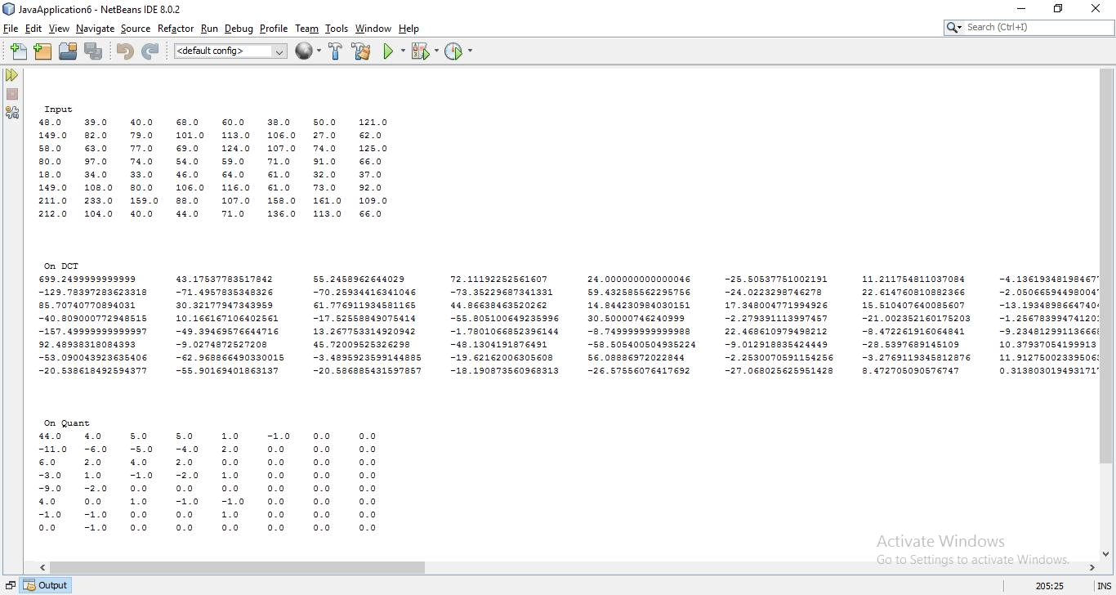

SVIT - VASAD Page 44

